15.72: a) , and the wave amplitude is
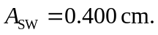The amplitude of the motion at the given points is (i) 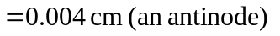 b). The time is half of the period, or 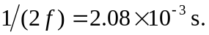 c) In each case, the maximum velocity is the amplitude multiplied by 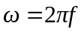and the maximum acceleration is the amplitude multiplied by

